ASSIGNMENT-1

**Name**: RITHIKA R

**College**: Sona College Of Technology

**Create a circuit with Piezoalarm, PIR sensor, and temp sensor with the below functionalities:**

1. Alarmshouldsoundinonemanneriftempisabove60degreeCelsius.
2. Alarmshouldsoundwithanotherfrequencyifmotionisdetected in PIR sensor.

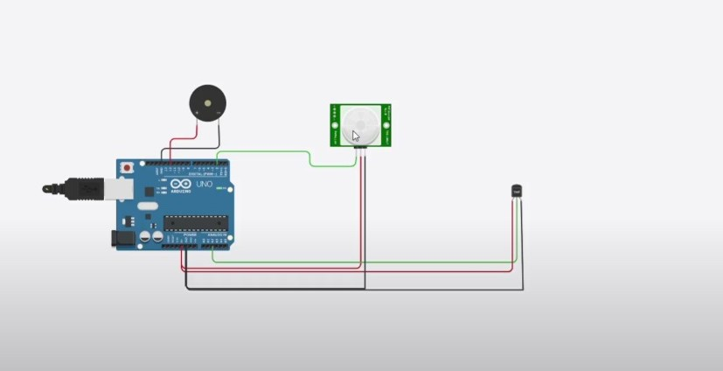

**CODING:**

void setup()

{

Serial.begin(9600);

pinMode(2,INPUT);

pinMode(12,OUTPUT);

}

void loop()

{

int motion=digitalRead(2);

if(motion==1){Serial.println("Moton detected");

tone(12,10);

delay(1000);

noTone(12);

delay(1000);

}

else{

Serial.println("Nomotion");

}

doubledata=analogRead(A2);

doublen=data/1024;

double volt=n*5;

doubleoff=volt-0.5;

double temperature=off*100;

Serial.print("Temperaturedata:");

Serial.println(temperature);

if(temperature>60.00)

{

tone(12,100);delay(500);noTone(12);delay(500);

}

}

**OUTPUT :**

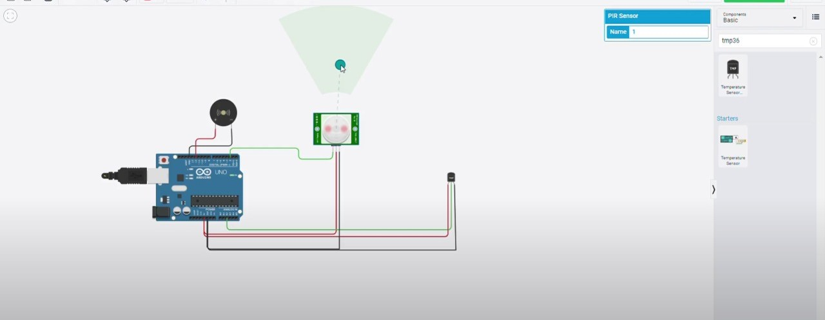

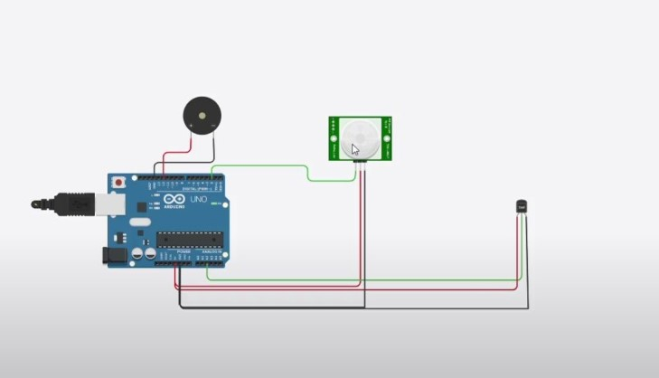

SIMULATIONLINK:

https://drive.google.com/file/d/1WsO0qm42ZsLrhDD1oAiO9JtdkCLeq38Q/view?usp=drivesdk